OFFICE OF THE PRESIDENT
DIRECTORATE OF SOCIO-ECONOMIC MONITORING AND RESEARCH (DSEMR)
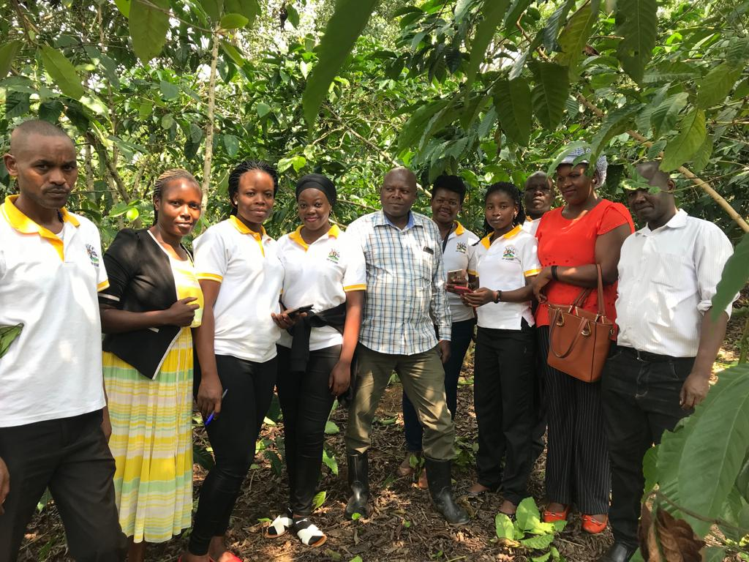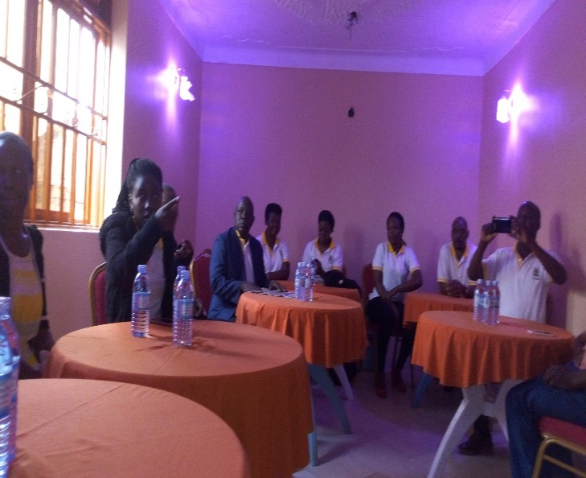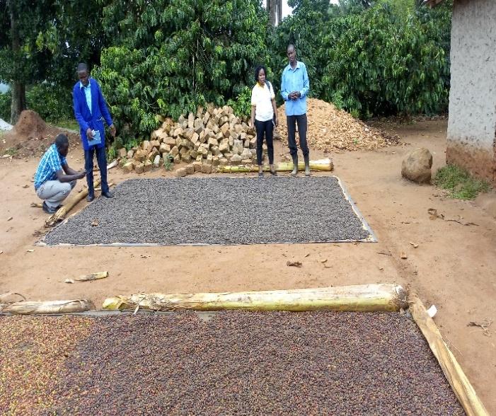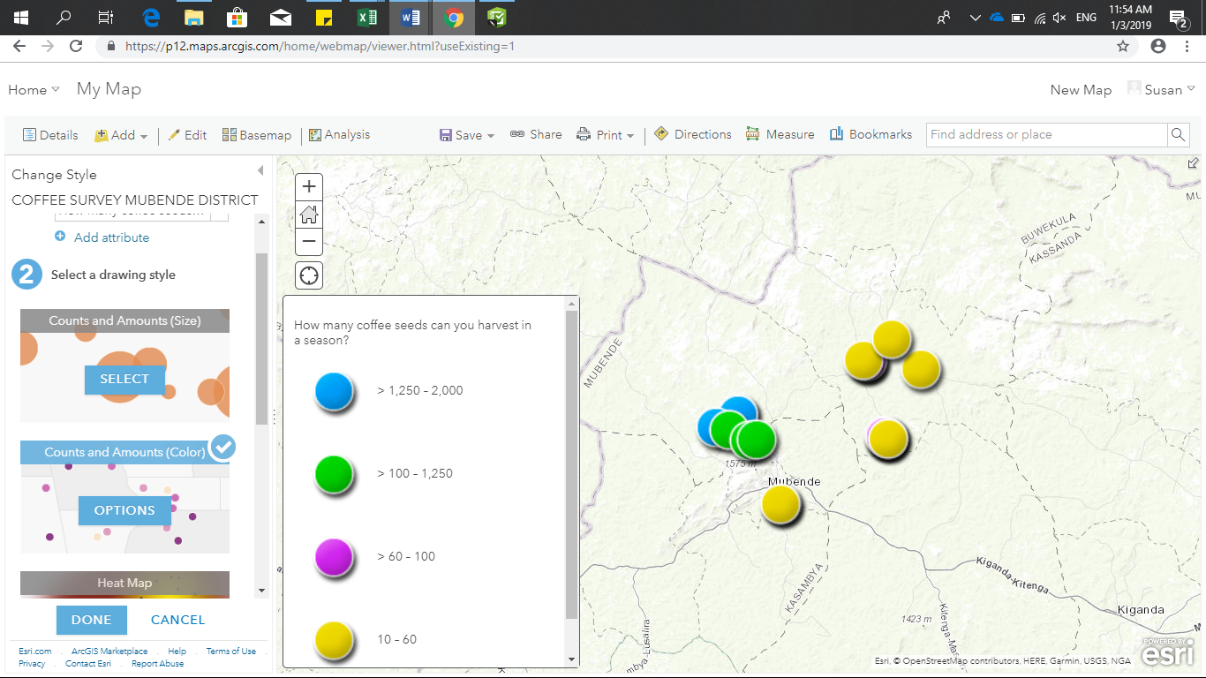
A REPORT ON GIS FOR SOCIO-ECONOMIC MONITORING AND RESEACH TRAINING; A CASE STUDY OF COFFEE PRODUCTION IN MUBENDE DISTRICT USED AS A PILOT
Theme: “For efficiency and effectiveness in executing our M&E function”
December 20th, 2018 – January 5th, 2019

Executive Summary
The Directorate of Socio-Economic Monitoring and Research (DSEMR) planned to carry out a training of all staff on Geographical Information System (GIS); an M&E tool used to monitor services delivery based on geographical location. This training was successfully conducted in the second Quarter of the FY 2018/19. The GIS training benefited both the technical and support staff. The training was held at Primerose Hotel in Mubende District from December 20^{th,} 2018 to January 5th, 2019 (for ten working days). For effectiveness, the training employed an adaptive learning approach that included; illustrations, practical exercises in the field, stakeholder/beneficiary engagement, field data collection and analysis. This aimed at illustrating to the participants the practical application of the tool.
The Directorate engages in field monitoring processes by collecting data to measure performance of key indicators and progress towards implementation of Government Policies, and Programs as a major Monitoring and Evaluation function. Previously, the Office has been using “hard copy “questionnaires to collect, analyze and store data. This has been quite cumbersome and wasteful of resources as a lot of paper, tonner, time and human resource are required in the process. With the initiative to venture into technology for Monitoring and Evaluation, the Directorate has explored the use of GIS, Open Data Kit (ODK) and Survey 123. These are applications integrated into one online ArcGIS platform that can as well be used offline on a desk top version to collect, analyze and store “REAL TIME” data for learning, quick decision making and improvements of polices and projects; as well as measure indicator performance. The training was therefore designed to build the capacity of DSEMR staff in the use of GIS (specifically ArcGIS online) as a digital data collection tool to improve the quality of data collected and enable the Directorate collect “REAL TIME” data using less time and limited resources; as well as timely design of questionnaires for improved data collection, analysis and storage.
The training was an exciting event, with participation by all staff, the facilitation was participatory and practical. The content covered included; an over view/introduction to GIS (how it works and all associated tools and terminologies), Using ArcGIS online (including account opening and management), Designing a questionnaire in ODK, uploading survey questionnaires using Survey 123, Data collection using Survey 123 and GPS applications, data collection, cleaning, analysis, reporting of results, Data exports (Excel, and CSV formats). A case study of coffee production in Mubende was used as a pilot.

Contents
Executive Summary i
1.0 Introduction 1
1.1 Background of GIS 1
2.0 Justification for conducting a training in GIS. 2
3.0 Objectives and scope of the GIS Training 2
3.1 Scope 3
3.1.1 Geographical scope 3
3.1.2 Content scope 3
4.0 Methodology 3
5.0 Training content/proceedings 4
5.1 Getting everyone on the same page 4
5.2 Introductions and welcome remarks. 4
5.3 A snap shot of the training 5
5.4 Expectations sharing/setting 5
5.5 Expected outcomes of the GIS training 5
5.6 Setting the training workshop norms. 6
5.7 The GIS Concept and its applications. 6
5.7.1 Why use GIS 6
5.7.2 GIS associated tools 7
5.7.3 Web Publishing of GIS data 7
5.7.4 GIS practical applications. 7
5.7.5 Sources of GIS data 8
5.7.6 Actual application of GIS in Research, Monitoring and Evaluation (RM&E) processes. 8
5.7.7 GIS application in RM&E decision making process 8
5.8 Top benefits of GIS 9
6.0 Getting acquainted with the practical applications of the GIS system 9
7.0 A brief on field findings from the pilot study conducted on Coffee production in Mubende District. 11
7.1 Characteristics of beneficiaries engaged in coffee production in Mubende District. 12
7.1.1 Gender disaggregation of beneficiaries 12
7.1.2 Age disaggregation of beneficiaries 13
7.2 Estimated income generated by beneficiaries from coffee production. 14
7.3 Coffee harvested by a farmer in the season 15
8.0 Review of expectations by participants of the training 15
9.0 Concluding Remarks 17
10.0 Observations and recommendations from the training. 17

List of Figures
Figure 1, DSEMR Team one, sub-team three interfacing with Mr.Kyambade Deo a coffee farmer in Mubunde Municipal Council 4
Figure 2, DSEMR Team one, sub-team three interviewing Mr. Ssekitoleko Josephant, a farmer from Mubende Municipal Council 4
Figure 3 DSEMR team collecting data from Mr. Turinawe Edward, a coffee farmer in Madudu sub-County, Mubende District using Survey 123 11
Figure 4.1: Pie chart presentation of gender disaggregation 12

List of Acronyms
CAO Chief Administrative Officer
CGIS Canada Geographic Information System
DISO District Internal Security Officer
DSEMR Directorate of Socio-Economic Monitoring and Research
GIS Geographical Information System
GPS Global Positioning System
M & E Monitoring and Evaluation
NGOs Non-Government Organizations

OWC Operation Wealth Creation
RDC Resident District Commissioner
UCDA Uganda Coffee Development Authority

1.0 Introduction
In December, 2018, through to January 6th, 2019, the Directorate of Socio-Economic Monitoring and Research (DSEMR) held a training on Geographical Information System (GIS); an M&E tool used to monitor and evaluate program performance at Primrose Hotel Limited, Mubende District. The training was aimed at equipping staff with M&E knowledge on the practical application of GIS for Socio-Economic Monitoring and Research. During the training, a practical pilot study was done on coffee production in Mubende District.
A “geographic information system” (GIS) is a computer-based tool that allows you to create, manipulate, analyze, store and display information based on its location.
Geographic information (that is; land information and spatial information) is information that can be associated with a place name, a street address, section/township, a zip code, or coordinates of latitude and longitude. A multitude of institutional function requires geographic information for example, property records and assessment, planning and zoning, permit tracking, natural resource management, infrastructure and transportation management, economic development planning, health and public safety. All these applications consider the location of certain features on the landscape in relation to other features. For instance, in assessment, the location of soil types relative to property parcels is considered, whereas in planning and zoning, the location of animal confinement facilities relative to residential areas might be relevant. A geographic information system (GIS) allows the user to examine and visualize these relationships.
This report therefore explains the proceedings of the training as well as the findings of the pilot study conducted on coffee production in Mubende District.

1.1 Background of GIS
The Directorate engages in a number of field activities to collect data on the performance of key government Policies, Programs and Projects as a key activity in its Monitoring and Evaluation exercises. Previously, the Office has been using “hard copy “questionnaires to collect and analyze data which has proved to be so wasteful in terms of resources as a lot of papers and tonners are required in preparation of these questionnaires as well as other associated costs such as time taken to formulate these questions.
The Office has over time experienced challenges in storing these “hard copy “questionnaires as some of them get misplaced during the data collection process, others are destroyed while in storage. These have proved to be a very big problem especially when the need to refer to these questionnaires arises.
The training therefore sought to build the capacity of staff in the DSEMR in the use of GIS as a digital data collection tool so as to improve the quality of data collected as well as minimize wastage of resources during both design and storage of the questionnaires. Use of GIS in data collection and analysis will also enable timely design of questionnaires as well as improved data analysis and storage.

2.0 Justification for conducting a training in GIS.
GIS being a digital data collection M&E tool makes it possible to integrate different kinds of geographic information, such as digital maps, aerial photographs, satellite images and global positioning system data (GPS), along with associated tabular database information (e.g., ‘attributes' or characteristics about geographic features). Using GIS, you can incorporate all this information into a single system and execute common database operations. For example, GIS allows you to perform statistical analysis or spatial queries, to explore ‘what-if' scenarios, and to create predictive models. GIS can help answer questions such as: i. what exists at a given location? ii. Where does something occur? iii. What has changed since a specific point in time? iv. What spatial patterns exist? v. What happens if…?
GIS allows you to examine and analyze geographic information at different levels of detail or from different perspectives. Then, it enables you to customize the display of your maps and analysis for presentation to particular audiences. It further enables effective and efficient data storage through creation of a network system online that can be exported for further analysis in excel and SPSS.

3.0 Objectives and scope of the GIS Training
The overall objective of the GIS training was to empower DSEMR staff to practically apply the concept of GIS as an M&E tool in performing their M&E function; mainly data collection, storage, analysis and reporting.

Specific Objectives
- To explain the concept and actual application of GIS in Research, Monitoring and Evaluation processes.
- To identify areas within which GIS can be used to inform M&E functions.
- To build capacity of participants in utilization of GIS & GPS, Infographics and its applications for better decision making and reporting processes.
- To embed GIS into the data collection exercise on Coffee production in Mubende District.

3.1 Scope

3.1.1 Geographical scope
The GIS training workshop was conducted at Primrose Hotel Limited in Mubende District, Central Uganda and the practical pilot data collection exercise was conducted in Madudu sub-county, Mubende District as well as Mubende District Municipal Council.

3.1.2 Content scope
The team focused on coffee production in Mubende District. The emphasis was on the composition of the coffee farmers by gender, age, experience in coffee production, acreage, estimated annual income, number of coffee seedlings planted, trainings received on planting, crop management, irrigation and post-harvest handling carried out by Uganda Coffee Development Authority (UCDA), Operation Wealth Creation (OWC) and other Non-Government Organizations (NGOs).

4.0 Methodology
The process involved participatory illustrative approaches to enable participants have a feel of the tool. Participants were introduced through an over view presentation to GIS applications and associated tools, a practical walk through ArcGIS online where participants were guided through a process to open and manage an account on the ArcGIS online platform. Participants were further guided on using Survey 123, Open data kit (ODK) used in data collection and questionnaire designs respectively. Participates were then engaged in a process to design a questionnaire using Survey 123 form (Questionnaire). The questionnaire was further used for data collection on coffee production in the field in Mubende.
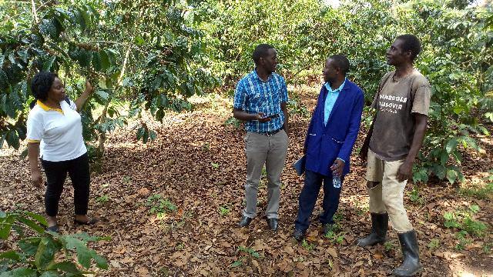  Figure 1, DSEMR Team one, sub-team three interfacing with Mr.Kyambade Deo a coffee farmer in Mubunde Municipality | 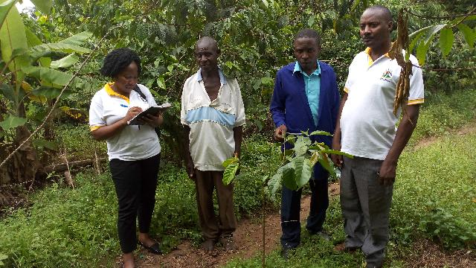  Figure 2, DSEMR Team one, sub-team three interviewing Mr. Ssekitoleko Josephant, a farmer from Mubende Municipality

The data collected using survey 123 questionnaire was then exported to excel work sheet, and CSV files for further analysis. Descriptive statistics was used to explain the data collected. The participants of the GIS training included both the technical and support staff of DSEMR as primary stakeholders. Because the training had a practical component of data collection, the District Local Government Staff who included RDC, DISO, CAO, District Production Officer, District Agricultural Officers, and Assistant District Agricultural Officer were adopted as secondary stakeholders to aid on security and link participants to coffee Farmers for the purpose of data collection

5.0 Training content/proceedings

5.1 Getting everyone on the same page
The participants introduced themselves to one another, giving insights on their names, occupation and their places of work.

5.2 Introductions and welcome remarks.
This session was led by the Director DSEMR who was the lead organizer of the training workshop. He said;
i. That he expected all members to pay maximum attention during the training.
ii. That, he was optimistic that the quality of our reports as well as data collected would greatly improve if the members put what they have acquired from the training into practice.
iii. That; going forward he expected the members to embed GIS in their M&E activities.
iv. That members should participate actively so that they learn faster.
v. That he expects a report from the training secretariat as soon as they get back to Office.

5.3 A snap shot of the training
This session was led by an Economist, who quickly took members through the purpose of the training and the proposed training agenda. The members were then asked to set their objectives as well as share their expectations from the training.

5.4 Expectations sharing/setting
The participants shared the following as their expectations from the training workshop;
They expected to;
- Gain knowledge on GIS.
- Know how GIS can be meaningfully linked to M&E.
- Get new knowledge to strengthen their M&E function.
- Be served good lunch from Primerose Hotel.
- Acquire new knowledge on using GIS in day to day work.
- Understand how to manipulate GIS into a report.
- Know how to build a data base used for storing data and also generate automatic reports from the stored data using GIS tool.
- Know how to locate spatial services within the country.
- Study any other application of GIS in their daily life.

5.5 Expected outcomes of the GIS training
The training facilitator explained that the outcomes of this training would be as follows;
- Cost Savings and increased efficiency: GIS was widely used to optimize maintenance schedules and daily fleet movements. Typical implementations can result in a savings of 10 to 30 percent in operational expenses through reduction in fuel use and staff time, improved customer service, and more efficient scheduling.
- Better decision making: GIS is the go-to technology for making better decisions about location. Common examples include real estate site selection, route/corridor selection, evacuation planning, conservation, natural resource extraction among others. Making correct decisions about location is critical to the success of an organization.
- Improved Communication: GIS based maps and visualizations greatly assist in understanding situations and in storytelling. They are a type of language that improves communication between different teams, departments, disciplines, professional fields, organizations and the public.
- Better record keeping: Many organizations have a primary responsibility of maintaining authoritative records about the status and change of geography. GIS provides a strong framework for managing these types of records with full transaction support and reporting tools.
- Managing geographically: GIS was becoming essential to understanding what is happening and what will happen in geographic space. Once we understand, we can prescribe action. This new approach to managing geographically is transforming the way that organizations operate.

5.6 Setting the training workshop norms.
The participants set and adopted the following norms during the training;
- To minimize unnecessary movements in and out of the training hall.
- To strictly adhere to the time allocated to each and every session.
- Mr. Deus Nkwasibwe was appointed the time keeper for the training.
- Every member was required to participate actively in all the sessions.
- Use of show of hands to raise issues or ask a clarification or question.
- To achieve 99.9 % of the members’ expectations set above.

5.7 The GIS Concept and its applications.
GIS is a computer based tool that allows the user to create, manipulate, analyze, store and display information based on its location. The concept of GIS helps the user to answer questions such as 1. What exists at a given location? 2. Where does something occur? 3. What has changed since a specific point in time? 4. What spatial patterns exist? 5. What happens if…?
Note: GIS produces information on maps.

5.7.1 Why use GIS
- GIS presents data in a compact and elegant method of communicating data.
- It provides easy to interpret information.
- It enables the user to customize the display of maps and make analysis for presentation to particular audiences.
- GIS allows the user to examine and analyze geographic information at different levels of detail or from different perspectives.

5.7.2 GIS associated tools
The GIS associated tools include;
Remote sensing devices which include; Aircrafts, Satellites among others. Remote sensing is the short or largescale acquisition of information of an object or phenomenon by recording, or real time sensing device(s) without physical or intimate contact with the object.
Global Positioning System (GPS) which refers to a satellite navigation system used to determine ground position coordinates. The GPS works in connection with worldwide satellite navigational systems, orbiting the earth and their corresponding receivers on the earth.

5.7.3 Web Publishing of GIS data
Web delivery of geographic data and maps allows the user to;
- Publish high quality interactive maps that can be accessed by thousands of people simultaneously over the Internet.
- Integrate data from multiple sources (Internet or local) and save it on the Web.
Illustration: Connect to ArcGIS online.
Exercise: Creating an online Arch GIS Account (explained in subsequent sessions)

5.7.4 GIS practical applications.
The facilitator generated a study area on an example of a coffee production program to illustrate to the team the practical application of GIS.
Example: A Coffee Production Program
“We want to think about locating all farmers that are on the program, to understand their production capacity in comparison to our target. Such information can help us make meaningful information.”

5.7.5 Sources of GIS data
The sources of GIS data include;
- Topographical maps (show a network of lines and a coordinate grid, so you can determine relative and absolute positions of mapped features).
- Aerial photography
- Satellite images.
- GPS coordinates.
- Shape files refer to a format for storing the geometric location and attribute information of geographic features represented by points (distinct locations, schools, health facilities among others), lines (roads, rivers), or polygons (areas/boundaries).
- Geodatabases refer to a "container" used to hold a collection of geographic datasets.
- Text files are used to record x, y, and z coordinates representing, longitude, latitude, and elevation, respectively.

5.7.6 Actual application of GIS in Research, Monitoring and Evaluation (RM&E) processes.
- GIS can be used to Collect Data during an Evaluation/research process (this was demonstrated practically).
- GIS in a development program helps to assess progress while considering geographic characteristics in reference to reliable baseline statistics.
- Using baseline data, project partners/ participants/stakeholders determine targets.

5.7.7 GIS application in RM&E decision making process
- Provides “better information” information that is faster, cheaper, more reliable, more readily available, and more understandable. (Ref: ArcGIS online)
- For usefulness in a decision-making process, you should carefully consider all facets of GIS implementation, technical, organizational, legal, and administrative.
- GIS use limits “Participation” in favor of professional expertise.
- Remember that successful use of GIS does not depend on technical choices alone. Organizational and institutional factors frequently are a greater barrier to successful GIS use.

5.8 Top benefits of GIS
The benefits of GIS include the following;
- Cost savings and increased efficiency: GIS is widely used to optimize maintenance schedules and daily fleet movements. Typical implementations can result in a savings of 10 to 30% in operational expenses through reduction in fuel use and staff time, improved customer service, and more efficient scheduling.
- Better Decision Making: GIS is the go-to technology for making better decisions about location. Common examples include real estate site selection, route/corridor selection, evacuation planning, conservation, natural resource extraction, among others. Making correct decisions about location is critical to the success of an organization.
- Improved Communication: GIS-based maps and visualizations greatly assist in understanding situations and in storytelling. They are a type of language that improves communication between different teams, departments, disciplines, professional fields, organizations, and the public.
- Better Record keeping: Many organizations have a primary responsibility of maintaining authoritative records about the status and change of geography. GIS provides a strong framework for managing these types of records with full transaction support and reporting tools.
- Managing Geographically: GIS is becoming essential to understanding what is happening and what will happen in geographic space. Once we understand, we can prescribe action. This new approach to management managing geographically is transforming the way that organizations operate.

6.0 Getting acquainted with the practical applications of the GIS system
Following the theoretical discussions above, the training proceeded to acquaint members with the practical applications of the GIS system.
The facilitators of the day requested members to get working partners. This was to ensure that no one was left behind.
They then asked members to turn on their gadgets (Their laptops and smart phones). They shared Arc GIS application system with the members and asked them to download the Survey 123 app into their phones such that they would tackle the first exercise that was earlier given. The best performer of this exercise was rewarded to boost morale of the participants.
Exercise One: A Coffee Production Program
“We want to think about locating all farmers that are on the program, to understand their production capacity in comparison to our target. Such information can help us make meaningful decisions.”
After creating accounts onto the Survey 123 system, together, the members then generated survey questions on the Arc GIS application system. They were then able to access these questions onto their form which they used to carry out a Mock survey.
The data collected was thereafter analyzed using the GIS system through manipulation of the system to produce spatial data and information illustrated in section seven below.
Photo I: DSEMR team collecting data using Survey 123 (Online ArcGIS application) on their phones.
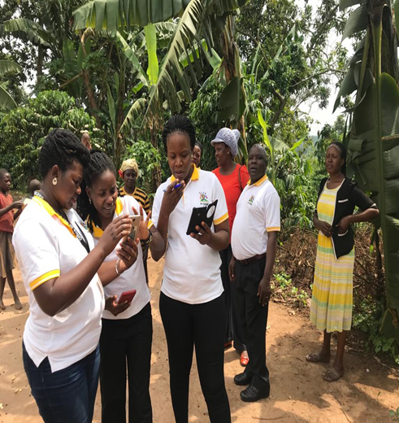  Figure3, DSEMR team having a practical hands-on application of the GIS system as they do the exercise given to them. | 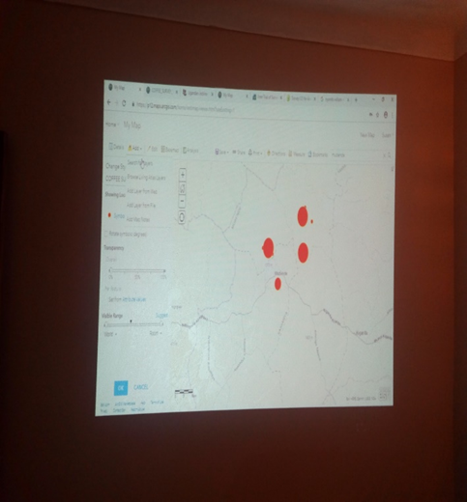  Figure 4, spatial data generated by the team from their mock survey exercise.

7.0 A brief on field findings from the pilot study conducted on Coffee production in Mubende District.
The members divided themselves into two major teams. These major teams were further sub-divided into sub teams. The first team interfaced with selected coffee farmers in Madudu Sub County, and the second team interfaced with coffee farmers within Mubende Municipality. Following the entry meeting at the District headquarters, each team was allocated a District Agricultural Officer as well as other District officers to aid the data collection exercise.
Photo II: Data collection in Madudu sub county.
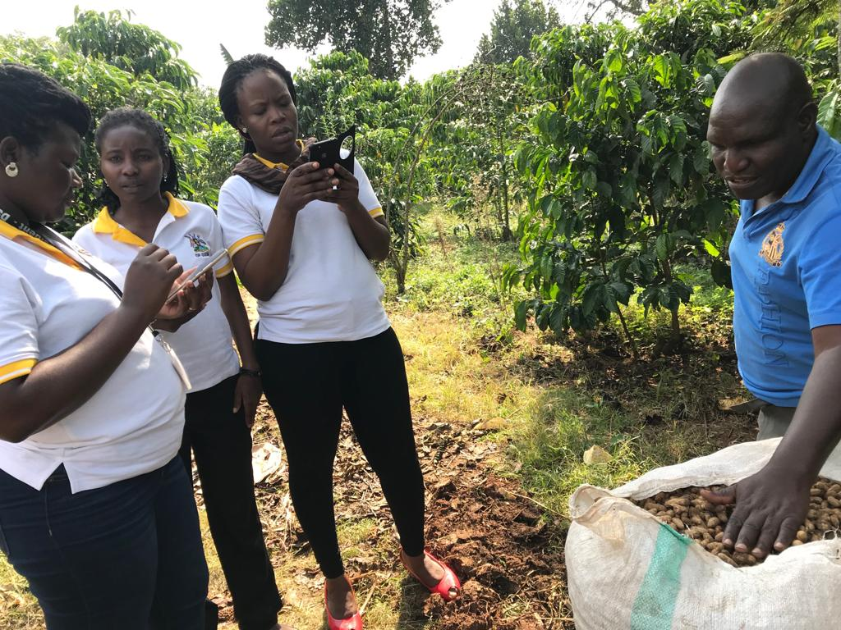
Figure 3 DSEMR team collecting data from Mr. Turinawe Edward, a coffee farmer in Madudu sub-County, Mubende District using Survey 123
After data collection was done; raw data collected using survey 123 and ODK was then exported in to excel from ArcGIS online; as shown in photo III below. This would enable further info graphics analysis.

Photo III: Data collected exported from ArcGIS online to Excel (.csv)
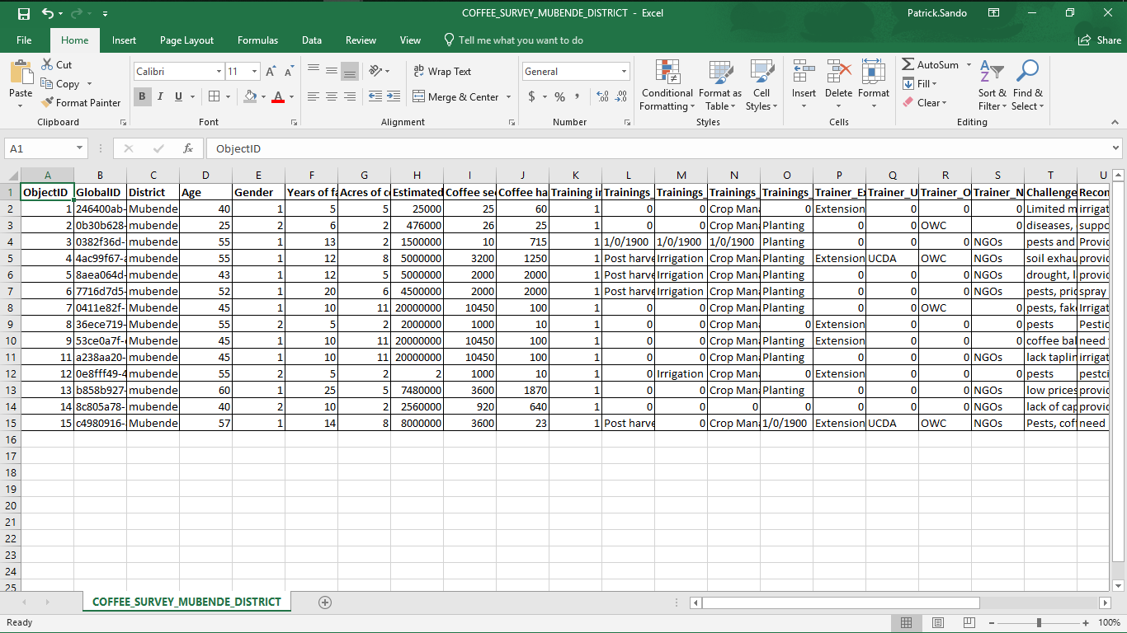
Source: Primary data through survey 123 application.

7.1 Characteristics of beneficiaries engaged in coffee production in Mubende District.
In understanding the characteristics of the beneficiaries; the study captured data on Gender and age composition of the beneficiaries as described in sections 7.7.1 and 7.1.2.

7.1.1 Gender disaggregation of beneficiaries
From the GIS illustration in figure 4 below; Gender composition of the respondents is seen to be of more male than female counter parts.

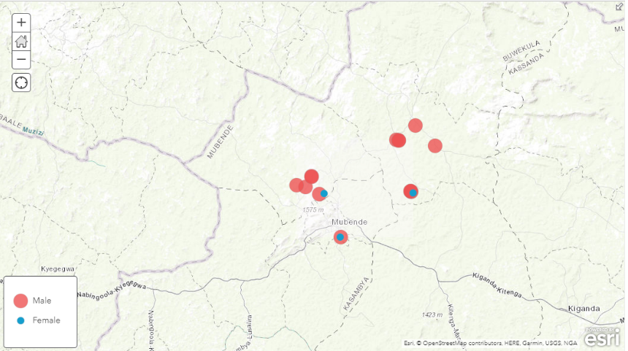
Figure 4.1: Pie chart presentation of gender disaggregation
Figure 4: Gender composition of respondents
Source: Primary data extracted from ArcGIS online
From these results; more male counter parts (71%) are beneficiaries of the program, compared to the female counter parts (29%). This was attributed to the land tenure system where more men own land compared to women. Therefore, the women cannot do any long term agriculture venture on the small pieces of land since they do not own it. Hence there is need to engage men in sensitization campaigns to allow women constructively do long term agriculture venture on the land.
Note: The same information was analysed using the exported excel file, and the result was as shown in figure 4.1 above

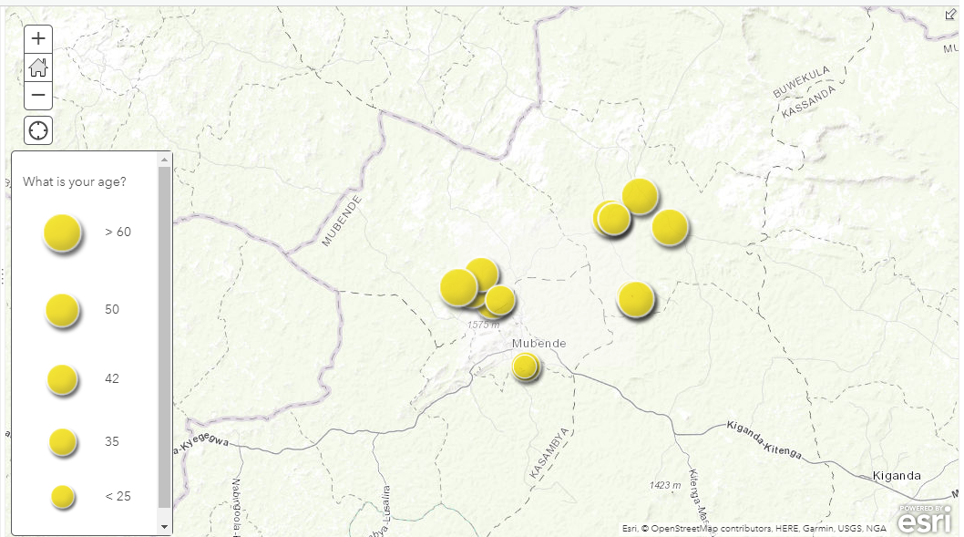
7.1.2 Age disaggregation of beneficiaries
Figure 5: Age desegregation of the respondents

Source: Primary data extracted from ArcGIS online
From the data presented in figure 5 above, the information generated shows that it is individuals above the age of 35 that are enagegd in coffee production compared to the younger individuals (youths), below 25 years. This was also attributed to the land ownership that is seen to be more owned by older individuals above the age of 35. This means that; coffee production is done more by the older people compared to the youths. Hence the need to engage youth more and finding ways on how to enable youth own land.

7.2 Estimated income generated by beneficiaries from coffee production.
Data on estimated income was collected to understand the estimated annual income that an individual can earn from coffee production. This visa vie the targets can be used to tell if the annuall target of income generated from coffee production can be achieved. Refer to figure 6 below.
Figure 6: Estimated annual income earned from coffee
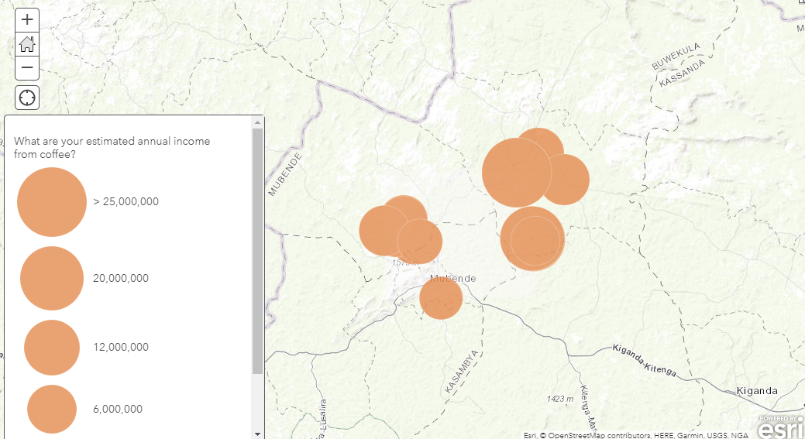
Source: Primary Data collecetd using Survey 123.
From the data generated; it is reflected that a farmer can earn atleast Ugx. 6,000,000 /=, and utmost Ugx 25, 000,000/= from coffee production annually. However this was dependent on the size of land and application of better agronomic practices in management of the coffee plantation. The more the land one owns and application of better management practices; the higher the income earned. On the other hand; more earnings are expected in rural areas compared to urban areas as seen on the map that farmers in Madudu earn more compared to those in the Municipality. Further more, it can be seen that, very few farmers (only two big curcles- > Ugx. 25,000,000 million) earn more than 25 Million shillings and the majority earn less than 12million.

7.3 Coffee harvested by a farmer in the season
The teams collected data on amount of coffee seeds a farmer can harvest in a season, This information can be used to guage the amount harvested in correlation with the target to understand the possibility of achieving the targets. The results generated are as reflected in figure 7 below.
Figure7: Coffee seeds harvested by farmers in a season
Source: Primary data collected through Survey 123.
From the information generated; it is reflected that more farmers harvest 10-60 bags of coffee in a season and very few produce more than 60 bags of coffee seeds in one season. This means that there is little produced in one season compared to the anticipated target of production in a season. There is therefore a need to engage farmers further to understand the causes of low production and hence support them effectively.
In a nutshell, from the data collected, section 7 above presents data analysed through ArcGIS and excel to show the content analysed during the training process. A lot more analysis could be done from the data collecetd but for training purposes, this was the analysis that could be done. Hence the possiblity of the GIS tool to collect, store, analyse and aid report generation.

8.0 Review of expectations by participants of the training
In view of the anticipated expectations from the training, the participants rated the training on a scale of 5-Excellent, 4- Very Good, 3_Good, 2-Fair, 1-Poor. The ratings were as follows;
Expectation one: Gain knowledge on GIS.
The participants awarded 5 to expectation one. They reasoned that they have acquired a lot of knowledge on the GIS concept and practical applications.

Expectation two: Know how GIS can be meaningfully linked to M&E.
The participants awarded 5 to expectation two.

Expectation three: Get new knowledge to strengthen their M&E function.
The participants awarded 5 to this expectation. They were particularly excited upon learning that questionnaires could be digitally designed using the tool.

Expectation four: Be served good lunch from Primerose Hotel.
The participants awarded 5 to this expectation. They were particularly happy that the meals were sumptuous as well as served on time. The quantity was also enough to satisfaction capacity.

Expectation five: Acquire new knowledge on using GIS in day to day work.
In regards to Expectation number five, they awarded 4 to it. They reasoned that the difference of one is due to the fact that the concept is still knew to them.

Expectation six: Understand how to manipulate GIS into a report.
They awarded 5 to this and attributed it to the fact that the training was very practical as the trainers took them through the data collection, analysis and manipulation of the system to generate reports.

Expectation seven: Know how to build a data base used for storing data and also generate automatic reports from the stored data using GIS tool. The participants awarded 5 to this expectation as it was practically done by all participants during the training as well as the pilot study.
Expectation eight: Know how to locate spatial services within the country.
The participants awarded 4 to this expectation. They reasoned that they were yet to experience this during more upcoming field exercises on distribution of social services. They however appreciated the function and hoped to experience it more frequently in the near future.

Expectation nine: Study any other application of GIS in their daily life.
The participants awarded 5 in relation to this expectation. They were excited to learn in particular that they could measure their plots of land using the system.

9.0 Concluding Remarks
The concluding remarks was given by the Commissioner, M&E and he had the following to say;
- The training met all his expectations as a person and was happy to know that same applied to all members as reflected in the above ratings of the training.
- He noted that the training was highly beneficial as it introduced a new concept that would make the Directorates’ M&E function more vibrant.
- He hoped that the members would not just shelf the knowledge acquired from the training but would rather put it into use.
- He said that members would now be judged whether they took the training seriously through the quality of their reports and data collected.
- He thanked the members for attending and actively participating in all sessions of the training.
- He thanked the trainers for accepting the Directorates’ invitations to conduct the training which has been so impactful.
- He wished members a safe journey back to Kampala.
- He thereby declared the training officially closed.

10.0 Observations and recommendations from the training.
- There is need for all DSEMR staff to have smart phones as the Directorate strives to move towards digitalizing its M&E function.
- There is need for the Directorate to consider paying for Arch-GIS annual subscription so that staff can easily access the GIS application system.
- There is need for the DSEMR staff to embed GIS applications into its M&E functions.
- There is need for the Directorate to maintain the practice of training its staff.
- There is need for DSEMR to procure tablets for officers to facilitate digital data collection exercises.

Annex
List of GIS training Participants.
LIST OF STAFF
S/N | NAME | DESIGNATION
1 | Mr. Tumusiime .B. Vincent | D/DSEMR
2 | Mr. Mugerwa George | COM/M&E
3 | Mr. Drani Peter Oyuga | PPA
4 | Mr. Olum Felix Nelly | PE
5 | Mr. Ekadu Eonyu Steven | Economist
6 | Mr. Nkwasibwe Deus | Economist
7 | Ms. Agenorwot Peace | Economist
8 | Ms. Nahabwe Monica | Economist
9 | Mr. Mugabi Crispus | Economist
10 | Ms. Namara Clare | Economist
11 | Ms. Akuse .B. Naume | SAS/DSEMR
12 | Ms. Namuwonge Hairat | Secretary
13 | Ms. Ssanyu Jennifer | Office Attendant
14 | Ms. Auma Susan | Office Attendant
15 | Mr. Tuhairwe Jackson | Office Attendant
16 | Mr. Seguya George | Driver
17 | Mr. Muhumuza Synab | Driver
18 | Mr. Tumushime Denis | Driver
19 | Mr. Ruberantwari Eric | Driver
20 | Mr. Kivumbi Ivan | Driver

